Guided Notes SC.912.L.18.9 – Explain the interrelated nature of photosynthesis and cellular respiration.
Key Point #1: ______________________________________________________________________
Photosynthesis
Equation: H₂O (_______) + CO₂ (__________) O₂ (_________) + C₆H₁₂0₆ (________)
Where does this process take place?
Cellular Respiration
Equation: O₂ (_________) + C₆H₁₂0₆ (________) H₂O (_______) + CO₂ (__________) + ____________
Where does this process take place?
Key Point #2: ____________________________________________________________________________
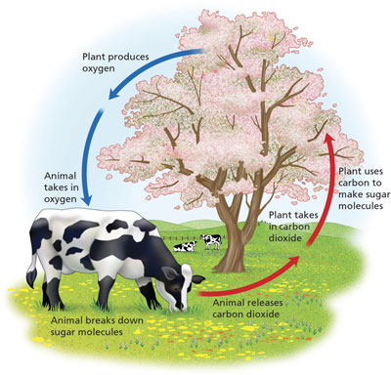

Key Point #3: _____________________________________________________________________________
Photosynthesis: Energy is captured by the sun and then transformed and stored in a glucose molecule.
Cellular Respiration: Energy is released from the glucose molecule and broken down to make ATP.

