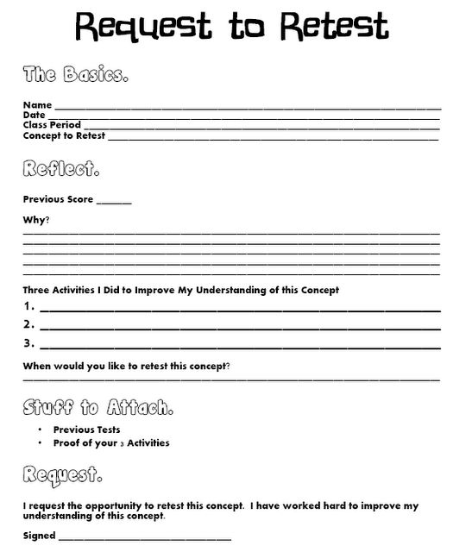
Parent signature: _____________________________________________________________________

