Plant Physiology – Guided Notes
Plants
- Just like other organisms, plants have ____________, tissues and cells.
Plant Tissues 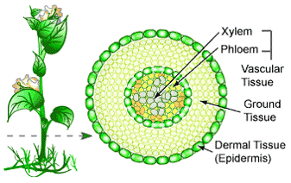
Plant Organs are made of four tissue systems:
- __________________________ covers the outside of a plant.
  - ________________ the plant
  - Secretes cuticle of leaves
  - Forms ____________ bark of trees
- __________________________ is found inside a plant.
  - provides _____________
  - Stores materials in roots and stems
- Meristematic Tissue consists of small, densely packed cells that can keep __________________ to form new cells.
  - Allow cells to stay forever young
  - Involved in plant _____________
- ______________________________ transports water, minerals and organic compounds.
  - Made of two networks of hollow tubes
  - ____________ transports water and minerals
  - ______________ transports photosynthetic products (water and sugar)

Plant Organs
Roots
- ____________ make up over half the body of the plant and provide many functions:
- ______________ the plant to the ground
-____________ water and minerals from the soil.
- Parts of a root:
  - ____________________ are tiny projections on the dermal cells of roots that aid in ______________________ of water and minerals
  - __________________ – a small cone of cells that ________________ the growing part of the root as it ______________ through the soil
- Roots also include the __________, ____________ and ______________ that aid in growth and movement of materials for __________________________ and transpiration.

Stems
- ____________ have many functions:
  - ______________ leaves and flowers

  - House most of the ________________ system
  - Store __________
  - Grow ______________________ for storage
  - Form ______ plants
- Stems also include ___________, ____________ and ________________ which aid in ____________, transpiration and _____________________________.

Leaves 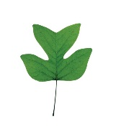
- Leaves are the site of ____________________________.
  - Absorb ________________ and carry out photosynthesis
All leaves have the same structure and function.
- The _________________ of the leaf is where the majority of the ________________________ are located that ______________ the sunlight.
- The __________________ of the leaf contain the _______________ and is the site of transpiration and ______ ________________.
- ______________________ surround each ______________
  - Stomata open and close when _______________________ change shape
  - When stomata are open, ____________ evaporates and _______ exchanges
  - Stomata ____________ at night and when the plant ____________ too much water

Flowers 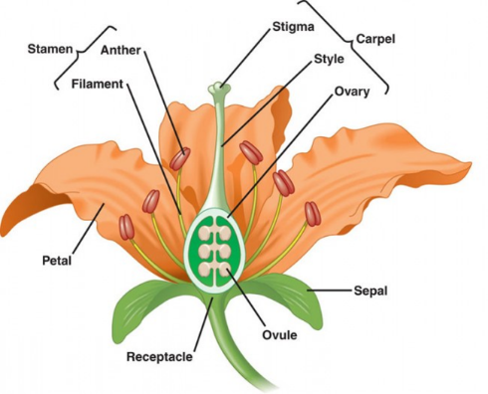
- ________________ are the _________________________ structure of flowering plants. They ______________ gametes and _______________________________.
Many parts make up the flower:
- __________: modified leaves that ______________ the developing flower.
- __________: Modified leaves that are ____________ in color to ________________ animal pollinators.
- Stamen: Male structure of flower. Includes the anther and the filament.
-____________ – Produce ____________ grains (sperm)
-__________________ – supports the ____________.
- Pistil (or carpel): Female structure of the flower. Includes the stigma, style and ovary.
-____________- covered with sticky substance to hold ____________ grains when they land.
-Style- a tube that leads from _____________ to ovary.
-____________- Base of flower where the ________ is produced.

Fruits
- A __________ is the mature __________ of a flower.
- It ________________ and protects the __________ or seeds
- Play an important role in seed ________________.
  - Blown in the __________ – ex. Dandelion
  - By ______________ ex. Stuck in animals fur or deposited after digestion
- Can come in many forms

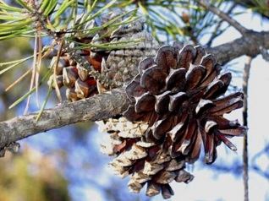
Cones
- __________ are __________________________ structures of plants that do not bear fruit.
- Cones contain hard protective scales
- Can be Male or Female:
  - __________ cones contain pollen (sperm).
  - ____________ are produced in ______________ cones.
  - Seeds also develop on the scales of ______________ cones.

