X`
Essential Question:
What role does the environment play in an organism’s survival and reproduction?

Name:
Class:
Period/Block:
Date:

Define: Natural Selection:

Questions/Main Ideas: Notes:
Darwin’s Natural Selection:  3 Requirements | 1.  2.  3..
The 4 main principles  of natural selection | 1.  2.  3.  4.
Natural Selection Steps | Step One:  Step Two:
Artificial Selection  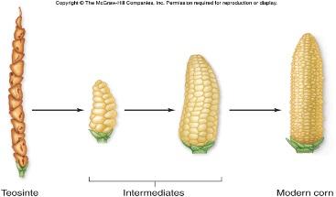 | - _________________ provides variation, _______________ select variations that are ___________________.
Natural Selection  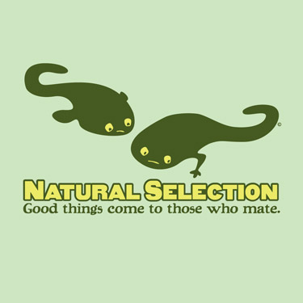 | INDIVIDUALS THAT HAVE TRAITS  THAT ARE BEST _________________FOR THE  CURRENT _____________________ ARE THE ONES THAT SURVIVE TO BREED AND PASS ON THEIR _______________TO THE NEXT __________________________.
Evolutionary Fitness | Evolutionary Fitness: The _____________________ that the line of descent from an individual with a specific trait will __________ die out.
Environmental  Change 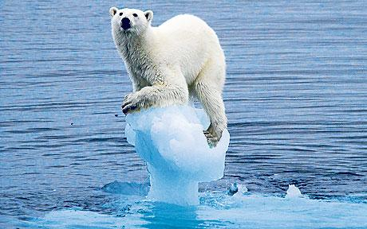 | When faced with a change in _______________ _______________, a population of a species can get MAD:  - _______________ to a more favorable location  - _______________ be adapted  - _______________
MUTATIONS  Selection pressure on a population: | Changes in the structure of the _______.  Adds ______________ ______________ to the population.  May or may not be _____________________.  Depends on the ________________  Gene Flow___________________________________________________  Genetic Drift____________________________________________________________________________________________________________________
Genetic Drift | Variation of alleles in a small population, and the ________________ that some genes may or may not be _____________ ____ to the next generation.
MASTERY QUESTION | How can a change in the environment initiate a change in a population?

