MACROMOLECULE FOLDABLE

Follow the directions below for creating your macromolecule. There are detailed directions for what you are to put on each tab. Be sure to put the correct information and correct side of the tab.
Fold and cut a piece of paper as shown below to make 4 tabs:
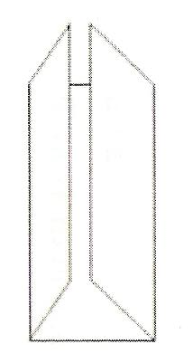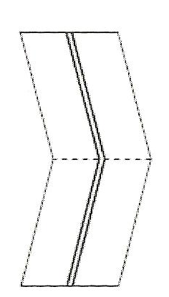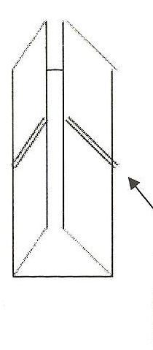
CUT
FRONT SIDE OF TABS:

Tab A
- Label the tab PROTEIN
- Sketch and color the AMINO ACID, SERINE (see Figure 2.15)

TAB B
- Label the tab CARBOHYDRATE
- Sketch and color a molecule of GLUCOSE (see page 45)

TAB C
- Label the tab LIPID
- Sketch, color and label a TRIGLYCERIDE or a PHOSPHOLIPID (see Figure 2.14)

TAB D
- Label the tab NUCLEIC ACID
- Sketch, color and label a NUCLEOTIDE (see page 230 in the Visual Vocab box)

(Continued on Back)…
BACK SIDE OF TABS:

TAB A
- Give 4 functions of proteins
- List 2 examples of proteins (serine is NOT a protein – see page 48 for examples)

TAB B
- Give the 2 functions of carbohydrates
- List 2 examples of monosaccharides and 2 examples of polysaccharides. Be sure to identify which ones are the monosaccharides and which ones are the polysaccharides.

TAB C
- Give 3 functions of lipids
- List 3 examples of lipids, one for each of the three functions. Be sure to clearly show which lipid is responsible for which function.

TAB D
- Give 1 function for nucleic acids
- List the 2 types of nucleic acids

ON THE INSIDE CENTER SECTION:
1. Center and write the word MACROMOLECULES in a large print. Underneath, write the definition for macromolecule.
2. Also add the terms “monomer” and “polymer” and write the definition of those terms as well.

ON THE BACK OF THE FOLDABLE, write your NAME and PERIOD.

