Name: Period:
SC.912.L.15.8 Describe the scientific explanations for the origin of life on Earth.

The diagram below shows a sequence of events illustrating a possible theory of the origins of life on Earth.

Stanley Miller and Harold Urey conducted an experiment to explain the origin of life on Earth.
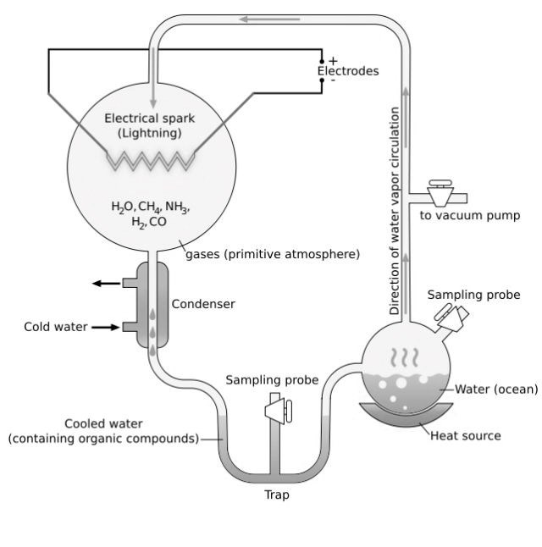

1
. Explain how their contributions helped in
the development of the scientific
explanation of the origin of life.

3
. Based on their theory, which gas was NOT
present in Earth’s early atmosphere?

. In which cellular process is this gas given
4
off as a by-product?

- Summarize how the contributions of the following scientists helped in the development of the scientific explanation of the origin of life.
Example: Miller Urey – evidence supporting the presence of organic molecules in Earth’s early atmosphere; reinforcing Oparin’s theory

Pasteur:

Oparin:

Margulis:

Fox:
- You are a scientist and have developed a new theory on the origin of life. How can your scientific claim be evaluated?

- Write the correct numbers under each letter below, for the correct order in the sequence of events in the endosymbiotic theory.

1 2 3 4
