Origins of life
What is the origin of life?
Even though scientifically the origin is

________________________, scientist do know that the earliest life form had to have had:

- _____________________________ – cloudy atmosphere, too much radiation for photosynthesis or chemosynthesis

- _____________________ – live without oxygen in the atmosphere (Earth was acidic/plate disruptions)

- Others? Single-celled, ____________________________, asexual binary fission
Louis Pasteur
Pasteur discovered the role of _________________ in fermentation. His experiments with bacteria conclusively
_________________________________ the theory of
_______________________________ generation and led to the theory that infection is caused by germs.
Alexander Oparin
Developed a theory that life on Earth

_________________________ through gradual chemical evolution of carbon-based molecules in

_____________________________ soup - the mix of gases in the

_____________________________ and the energy from lightning strikes, amino acids could
__________________________________ form in the oceans.
Lynn Margulis
Best known for her theory on the origin of

____________________ organelles, and her contributions to the

_____________________________ theory, which is now generally accepted for how certain organelles were formed.
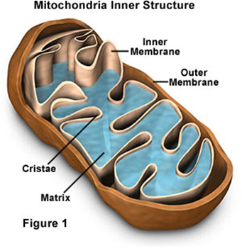
Evidence of endosymbiosis
Chloroplast and Mitochondria
- Double membranes
  - Outer membrane is of

________________________ origin
  - Inner membrane is of

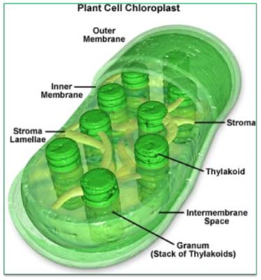
________________________ origin
- Single loop of DNA
- Reproduce by binary fission

- Have _____________________ of prokaryotic origin
- About the same size as

_______________________________
Miller – Urey
Stanley Miller and Harold Urey, conducted an experiment which
______________________________ that several organic compounds could be
formed _______________________________________ by simulating the conditions of Earth's early atmosphere. They designed an apparatus which held
a mix of ________________________ similar to those found in Earth's early
_________________________________________________ over a pool of water, representing Earth's early ocean. Electrodes delivered an electric current, simulating lightning, into the gas-filled chamber.
Sidney Fox
The production of ______________ acids from inorganic molecules.
Fox based his experiments off of the information found in the __________
_____________ experiment. He demonstrated that amino acids could
spontaneously form small ______________________________. These amino acids and small peptides could be encouraged to form closed spherical
_____________________________________________, which
show many of the basic _________________________________ of 'life.

Three scenarios have been proposed for the origin of life:
- organic molecules :
  - were ________________________________ from inorganic compounds in the atmosphere
  - rained down on _________________ from outer space;
  - were synthesized at ___________________ vents on the ocean floor.
Chemical evolution
- The formation (synthesis) of complex __________________ molecules from simpler inorganic molecules through chemical reactions in the oceans during the early history of the Earth
Endosymbiotic theory
- A ___________________ is an organism whose cells contain complex structures enclosed within membranes, which takes a big part in the building blocks of life. This
_____________ postulates that several key organelles of eukaryotes originated as symbioses between separate single-celled organisms. According to this theory,
____________________________, plastids and possibly w that were taken inside another cell as an endosymbiont.

