SC.912.L.14.1 - Describe the scientific theory of cells (cell theory) and relate the history of its discovery to the process of science.
SC.912.N.3.1 – Explain that a scientific theory is the culmination of many scientific investigations drawing together all the current evidence concerning a substantial range of phenomena; thus, a scientific theory represents the most powerful explanation scientists have to offer.
Reference the How Science Works Flowchart and The Cell Theory Video for the questions below.
- 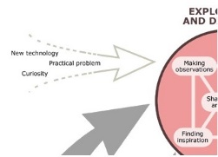What new technology was developed in the early 1600’s that initiated the process of scientific study that would lead to the discovery of the cell?___________________________________________________
- 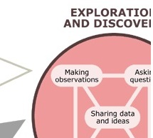How did Leeuwenhoek discover bacteria? ___________________________________________
- 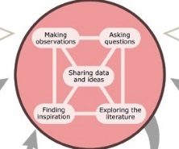With whom was Leeuwenhoek sharing his ideas? ______________________________________
- 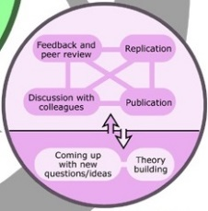Who did Hooke believe stole his ideas? ______________________________________________
- 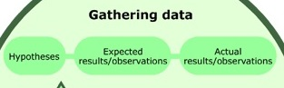 What did Schleiden realize after years of observations? ___________________________________________________________________________________________
- 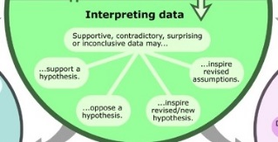 How did Schwann’s observations support Schleiden’s? ___________________________________________________________________________________________
- 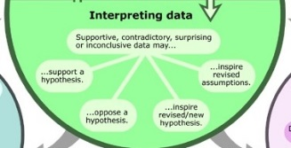 On what part of the current cell theory did Schleiden and Schwann disagree? ___________________________________________________________________________________________
- 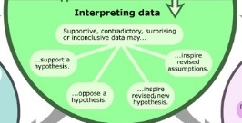What scientist’s observations helped settle the disagreement between Schleiden and Schwann? ___________________________________________________________________________________________
- What are the three parts of the cell theory? ___________________________________________________________________________________________

