CHAPTER 1: NATURE OF SCIENCE
- Objective SC.912.N.1.1: Define a problem based on a specific body of knowledge and demonstrate the scientific method to investigate the problem.
Vocabulary
Science:__________________________________________________________________________________________________
Observation:______________________________________________________________________________________________
Hypothesis:_______________________________________________________________________________________________
Independent Variable:______________________________________________________________________________________
Dependent Variable:_______________________________________________________________________________________
Control Group:____________________________________________________________________________________________ Scientific Theory:__________________________________________________________________________________________
Scientific Law:_____________________________________________________________________________________________
Short Answer
- What are the goals of science?
- Describe a controlled experiment:
- How is a hypothesis tested?
- Can a hypothesis become a theory? Why or why not?
- What is the difference between a theory and a law?
- Why can’t scientific theories become scientific laws?
- What are the characteristics of living things?
CHAPTER 2: BIOCHEMISTRY
- Objective SC.912.L.18.12: Discuss the special properties of water that contribute to Earth’s sustainability as an environment for life: cohesive behavior, ability to moderate temperature, expansion upon freezing, and versatility as a solvent.
Vocabulary
Hydrogen Bond: ___________________________________________________________________________________________
Cohesion: ________________________________________________________________________________________________
Adhesion: ________________________________________________________________________________________________
- How does heat capacity affect temperature change?

- How does the polarity of water affect heat capacity?

- Objective SC.912.L.18.1: Describe the basic molecular structures and primary functions of the four major categories of biological macromolecules.
Vocabulary
Carbohydrates: ___________________________________________________________________________________________
Monosaccharide: __________________________________________________________________________________________
Lipids: ___________________________________________________________________________________________________
Nucleic Acids: _____________________________________________________________________________________________
Nucleotides: ______________________________________________________________________________________________
Proteins: _________________________________________________________________________________________________
Amino Acids: _____________________________________________________________________________________________
Activation Energy: _________________________________________________________________________________________
Short Answer
- What organic compound provides the primary source of energy for living things?
- What is the main purpose of DNA?
- Explain the role of enzymes and how they affect chemical reactions.
- How do factors, such as temperature and pH, affect enzyme activity?
CHAPTER 7: CELLS
- Objective SC.912.L.14.1: Describe the scientific theory of cells (cell theory) and relate the history of its discovery to the scientific process of science.
Vocabulary
Cell Theory: ______________________________________________________________________________________________
_____________________________________________________________________________________________
- Objective SC.912.L.14.3: Compare and Contrast the general structures of plant and animal cells. Compare and contrast the general structures of prokaryotic and eukaryotic cells.
Vocabulary
Prokaryote: ______________________________________________________________________________________________
Eukaryote: _______________________________________________________________________________________________
Nucleus: _________________________________________________________________________________________________
Mitochondria: ____________________________________________________________________________________________
Endoplasmic Reticulum: ____________________________________________________________________________________
Ribosomes: ______________________________________________________________________________________________
Chloroplasts: _____________________________________________________________________________________________
Cell Membrane: ___________________________________________________________________________________________
Diffusion: ________________________________________________________________________________________________
Facilitated Diffusion: _______________________________________________________________________________________
Osmosis: _________________________________________________________________________________________________
Short Answer
- What organelles are found in both prokaryotic and eukaryotic cells?
- What are plant cell wells composed of?
- What are the 3 distinguishing structural differences between plant and animal cells?
- Compare and contrast passive and active transport:
- What happens to a cell placed in a hypertonic solution and why does that happen?
- What happens to a cell placed in a hypotonic solution and why does that happen?
Identify the cell types below and label all of the organelles and structures indicated:
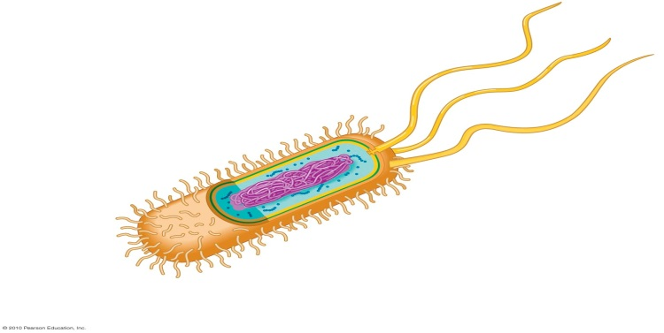

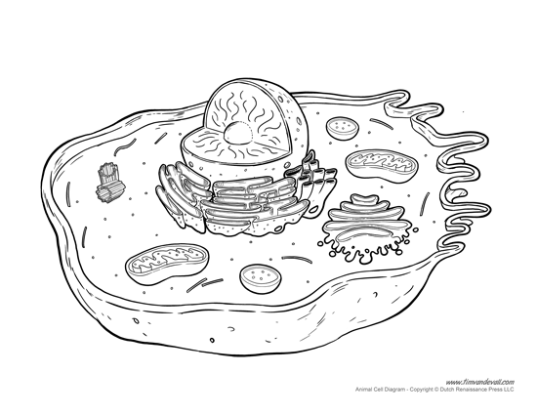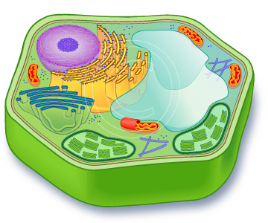

CHAPTERS 8 & 9: PHOTOSYNTHESIS AND CELLULAR RESPIRATION
- Objective SC.912.L.18.9 Explain the interrelated nature of photosynthesis and cellular respiration.
Vocabulary
ATP: ___________________________________________________________________________________________________
Chlorophyll: _____________________________________________________________________________________________
Photosynthesis: __________________________________________________________________________________________
Light Dependent Reactions: ________________________________________________________________________________
Light Independent Reactions: _______________________________________________________________________________
Cellular Respiration: ______________________________________________________________________________________
Aerobic: ________________________________________________________________________________________________
Anaerobic: ______________________________________________________________________________________________
Lactic Acid: ______________________________________________________________________________________________
Short Answer
- How does the structure of ATP allow it to function in the transfer of energy within a cell?
- What are the reactants and products of photosynthesis?
- What are the reactants and products of cellular respiration?
- Why is aerobic respiration considered a more efficient use of glucose than anaerobic respiration?
- How are photosynthesis and cellular respiration interrelated?
- Why do plant cells need both chloroplasts and mitochondria?
CHAPTERS 12 &13: DNA & PROTEIN SYNTHESIS
- Objective SC.912.L.16.3: Describe the basic process of DNA replication and how it relates to the transmission and conservation of the genetic information.
Vocabulary
Nucleotide: _____________________________________________________________________________________________
Replication: _____________________________________________________________________________________________
Short Answer
- What would be the complimentary DNA strand to the following: CGAAGTTCG
- What is meant by the universal genetic code?

