____karyotic Cell  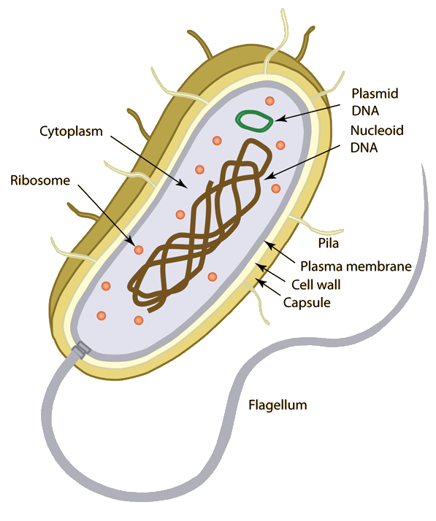  - Have genetic material called________________  - DNA is found in__________________________  - Lacks membrane bound ___________________ such as mitochondria and Rough ER  - Usually _____________ in the level of complexity  - Usually ____________________________ in size  - These cells are ____________ cellular organisms  Additional Notes: | ____karyotic Cell  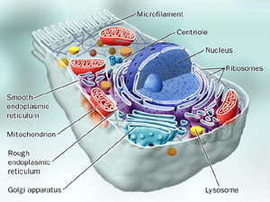  - Have genetic material called ________________  - DNA is found in___________________________  - Has membrane bound _________________ such as chloroplast and golgi bodies  - Usually ______________ in the level of complexity  - Usually __________________________ in size  - These cells are __________ cellular organisms  Additional Notes:

